To: | Cabinet
Date: | 15 December 2021
Report of: | Head of Financial Services
Title of Report: | Treasury Management Mid-Year Review for April – September 2021

Summary and recommendations
Purpose of report: |  | To report on the performance of the Treasury Management function for the 6 months to 30 September 2021
Key decision: |  | No
Executive Board Member: |  | Councillor Ed Turner, (Deputy Leader) Finance and Corporate Assets
Corporate Priority: |  | None
Policy Framework: |  | Council Strategy 2020-24
Recommendation: That Cabinet resolves to:
1. | Note the performance of the Treasury Management function for the six months to 30th September 2021

Appendices
Appendix 1 | List of investments as at 30th September 2021
Appendix 2 | Risk Register

Introduction and Background
- This report has been written in accordance with the requirements of the Chartered Institute of Public Finance and Accountancy’s (CIPFA) Code of Practice on Treasury and has been prepared in compliance with CIPFA’s Code of Practice on Treasury Management, covering the following:
- An economic overview for the first part of the 2021/22 financial year
- A review of the Council’s investment portfolio for 2021/22
- A review of the Council’s borrowing strategy for 2021/22
- A statement of compliance with Treasury and Prudential Limits for 2021/22
- The Council operates a balanced budget, which broadly means cash raised during the year will meet its cash expenditure. Part of the treasury management operations ensure this cash flow is adequately planned, with surplus monies being invested in suitable counterparties, providing adequate liquidity and security initially before considering optimising investment return.
- The second main function of the treasury management service is the funding of the Council’s capital plans. These capital plans provide a guide to the borrowing need of the Council, essentially the longer term cash flow planning to ensure the Council can meet its capital spending operations. This management of longer term cash may involve arranging long or short term loans, or using longer term cash flow surpluses, and on occasion any debt previously drawn may be restructured to meet Council risk or cost objectives.
- The budgeted investment income for 2021/22 is £0.805 million. As at the 30th September 2021, forecast investment income for 2021/22 is £0.997m. Overall gross interest, including cost of borrowing, is forecast to be beneficial at £211k higher than budget. There are a number of factors giving rise to this overall position:
- External borrowing is less than anticipated due to delays in the capital programme;
- Minimum revenue provision costs are lower as a consequence of less borrowing;
- Lower than anticipated lending to companies resulting in less interest income from the loans;
- The delays in in the capital programme has resulted in higher than anticipated cash for investment resulting in the positive investment interest forecast.
Economic Overview
- The Monetary Policy Committee (MPC) voted 7 to 3 at its 4th November meeting to leave Bank Rate unchanged at 0.10% and made no changes to its programme of quantitative easing purchases due to finish by the end of this year at a total of £895bn.
- CPI is forecast to rise to 5% by April next year. The MPC has made it clear that interest rates will have to rise to counter this inflation increase and, because the MPC has previously reviewed quarterly monetary policy reports prior to agreeing to rate changes, it is likely that a rate increase will not take occur until February next year. The October CPI results were +1.1% month on month and +4.2% year on year against forecasts of +0.8% and +3.9% respectively.

- Financial markets are now pricing in a first increase in Bank Rate from 0.10% to 0.25% in February 2022. There is uncertainty around this because the MPC has stated that it wants to see what happens to the economy, and particularly to employment, once furlough ends at the end of September. At the MPC’s meeting in February it will only have the employment figures for November available and will only get the data to February at its May meeting. At its May meeting, it will also have a clearer understanding of what is happening with inflation.
- The MPC’s forward guidance on its intended monetary policy on raising Bank Rate versus selling (quantitative easing) holdings of bonds is as follows: -
- Placing the focus on raising Bank Rate as “the active instrument in most circumstances”.
- Raising Bank Rate to 0.50% before starting on reducing its holdings.
- Once Bank Rate is at 0.50% it would stop reinvesting maturing gilts.
- Once Bank Rate had risen to at least 1%, it would start selling its holdings.
Interest and Interest Rate Forecasts
- The Council’s treasury advisor, Link Group, provided the following forecasts (PWLB rates are certainty rates, gilt yields plus 80bps):
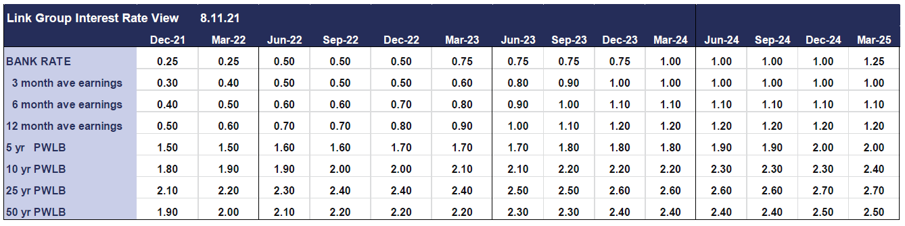
- The coronavirus outbreak has done huge economic damage to the UK and to economies around the world. After the Bank of England took emergency action in March 2020 to cut Bank Rate to 0.10% and has left the Bank Rate unchanged at its subsequent meetings.
- As shown in the forecast table above, the Council’s treasury advisors are forecasting one increase in Bank Rate from 0.10% to 0.25% in quarter 4 of 2021/22, a second increase to 0.50% in quarter 2 of 22/23 and a third one to 0.75% in quarter 1 of 22/23.
- Bank Rate is not expected to go up fast after the initial rate rise as the supply potential of the economy has not generally taken a major hit during the pandemic, so should be able to cope well with meeting demand without causing inflation to remain elevated in the medium-term, or to inhibit inflation from falling back towards the MPC’s 2% target after the increase to around 4% towards the end of 2021. Three increases in Bank rate are forecast in the period to March 2024, ending at 0.75%, however, these forecasts may well need changing within a relatively short time frame for the following reasons: -
- There are increasing grounds for expecting the economic recovery to slow during the summer and now into the autumn.
- Current key supply shortages, e.g. petrol and diesel, could impact on economic activity in some sectors.
- Rising gas and electricity prices in October and next April and increases in other prices caused by supply shortages and increases in taxation next April, are already likely to reduce consumer spending power without the MPC having to take any action on Bank Rate.
- The market is assuming that consumers have around £200bn of excess cash left over from the pandemic; if this is spent in part or total then this will impact the economy.
- There are 1.6 million people coming off furlough at the end of September and the effect of this may take a few months to properly impact and potentially fill labour shortages in the economy. Supply shortages have been driving up both wages and costs and if these reduce significantly within the next six months this would alleviate the MPC’s current concerns.
- There is also a risk that there could be further negative impacts from Covid, on top of the flu season this winter, which could depress economic activity.

In summary, with the high level of uncertainty, it is likely that these forecasts will need to be revised again soon.

Forecasts for PWLB rates and gilt and treasury yields
- As the interest forecast table for PWLB certainty rates above shows, there is likely to be a steady rise over the forecast period, with some degree of uplift due to rising treasury yields in the US.
- There is likely to be exceptional volatility and unpredictability in respect of gilt yields and PWLB rates due to the following factors: -
- How changes in gilt yields correlate to changes in US treasury yields
- Whether the MPC act to counter increasing gilt yields if they rise beyond a yet unspecified level
- How strong inflationary pressures are in both the US and the UK and the consequent impact on treasury and gilt yields
- How central banks implement their new average or sustainable level inflation monetary policies
- How central banks manage the withdrawal of QE purchases of their national bonds i.e., without causing a panic reaction in financial markets.
- Whether any exceptional volatility will be focused on the short or long-end of the yield curve, or both
- The forecasts are also predicated on an assumption that there is no break-up of the Eurozone or EU within the forecasting period and that there are no major ructions in international relations, especially between the US and China / North Korea and Iran, which have a major impact on international trade and world GDP growth.

Investment Portfolio and Performance
- The budgeted investment income for 2021/22 is £0.805 million. As at the 30th September 2021, forecast investment income for 2021/22 is £0.997m.
- Overall gross interest, including cost of borrowing, is forecast to be beneficial at £211k higher than budget. External borrowing has been less than anticipated due to delays in the capital programme along with lower than anticipated lending to companies this has meant a higher than anticipated cash for investment both resulting in the positive interest forecast.
- The Treasury Management Strategy for 2021/22 was approved by this Council in February 2021; to date the Strategy has been fully adhered to.
- As part of its Strategy, the Council aims to maintain a diversified investment portfolio whilst ensuring there are no policy and procedure breaches. Security of investments is always the primary concern when arranging investments with liquidity and yield being secondary, but key considerations.
- The Council operates an approved counterparty listing which details all institutions with whom the Council may invest, the maximum amount which may be invested with any single counterparty group at any given point and the maximum duration period. The counterparty list is set in association with recommendations from Link Asset Services although ultimate authorisation of approved counterparties rests with the Section 151 Officer. The list is actively managed and reviewed on a weekly basis or more regularly if required.
- Monthly monitoring meetings are held with the Section 151 Officer, Financial Accounting Manager and Treasury staff to discuss investments in terms of counterparties and maturity dates, cash flow, interest and borrowing rates and Treasury operational and Strategic strategies.
- The strategy also adopts an ethical approach to investments, stating that:
“The Council will not knowingly invest directly in businesses whose activities and practices pose a risk of serious harm to individuals or groups, or whose activities are inconsistent with the Council’s mission and values. This would include, inter alia, avoiding direct investment in institutions with material links to:
- Human rights abuse (e.g. child labour, political oppression)
- Environmentally harmful activities (e.g. pollutants, destruction of habitat, fossil fuels)
- Socially harmful activities (e.g. tobacco, gambling)”
- The current approach to Environmental & Social governance (ESG) is to weigh up ESG criteria into account when choosing new investment providers as one of the matters that we consider, however under the Treasury Management Code we have to prioritise Security, Liquidity and Yield factors. ESG criteria are used as an overlay to this.
- We have reached out to our current investment providers to give us a breakdown of their ESG principles and provide any information they have on their ESG credentials and we regularly question investment partners on their policies when we meet with them to discuss our investments.
- It should be noted that ESG information is not always available and not always consistent across counterparties
- The intention is for the Treasury Strategy for 2022/23 to outline a more detailed policy with regards to Environmental & Social governance

Property Investment Funds
- At present, the Council has placed investments with two property funds; CCLA Investment Management, which is a property fund that limits its investors to Charities, Churches and Local Authorities and Lothbury Investment Management, a specialist UK property fund manager with a range of funds providing high quality exposure to different property sectors. Property values have recovered from the shock of the Covid Pandemic and are still giving us a good return on our investments. Both property funds have reduced their retail holdings which de-risks the capital value they hold.
- Changes to the accounting rules on pooled investment funds means that the principal gain or loss will now be charged to the Surplus or Deficit on the Provision of Services, within the Councils Income and Expenditure Account, rather than being held on the balance sheet. However, following consultation by MHCLG the government has introduced a mandatory statutory override for local authorities to reverse out the effect for five years from 1st April 2018 after which surpluses as well as deficit will impact on the Councils revenue position. Even without the statutory override, the Council would have created a reserve to hold the funds until the return was realised due to the potential for fluctuations in the property markets.
CCLA Investment Management Limited
- The Council has held a £3m investment in the CCLA fund since September 2013. The investment has produced quarterly returns ranging between 5% and 6% and it is expected that the Fund will continue to achieve rates in this region.
- Additionally, the value of the Council’s investment with CCLA has appreciated from £3m to £4m as at 30th September 2021, equating to growth of 33.35% to date from inception. However, the values of the individual unit prices have fluctuated over time and the effect of capital appreciation (and depreciation) is illustrated in the graph below. There has been pressure on the overall property value but the dividend is being maintained and prices are always going to fluctuate over time. This is seen as a long term investment.

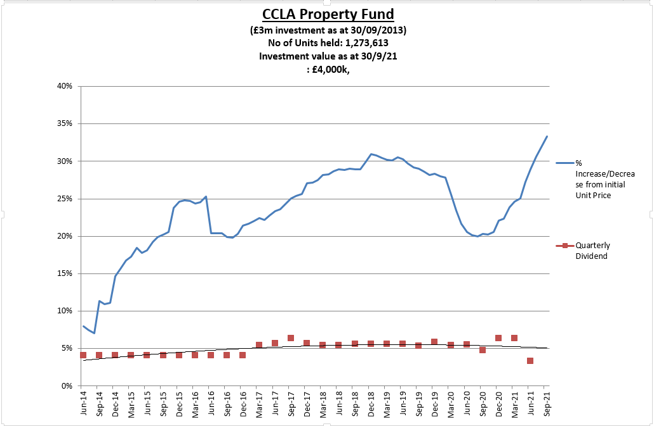

- The investment returns around £40k per quarter.
Lothbury Investment Management
- During 2014/15, the Council invested £7m in the Lothbury Property fund and the Fund has produced quarterly returns in the range of 3-4%. Furthermore, the Fund has seen a capital appreciation over the period with the value currently standing at £8.158m, compared with £7m at inception, equating to overall growth of 20.60% to date. However, as with CCLA, the values of the individual unit prices have fluctuated over time and the effect of capital appreciation (and depreciation) is illustrated in the graph below.

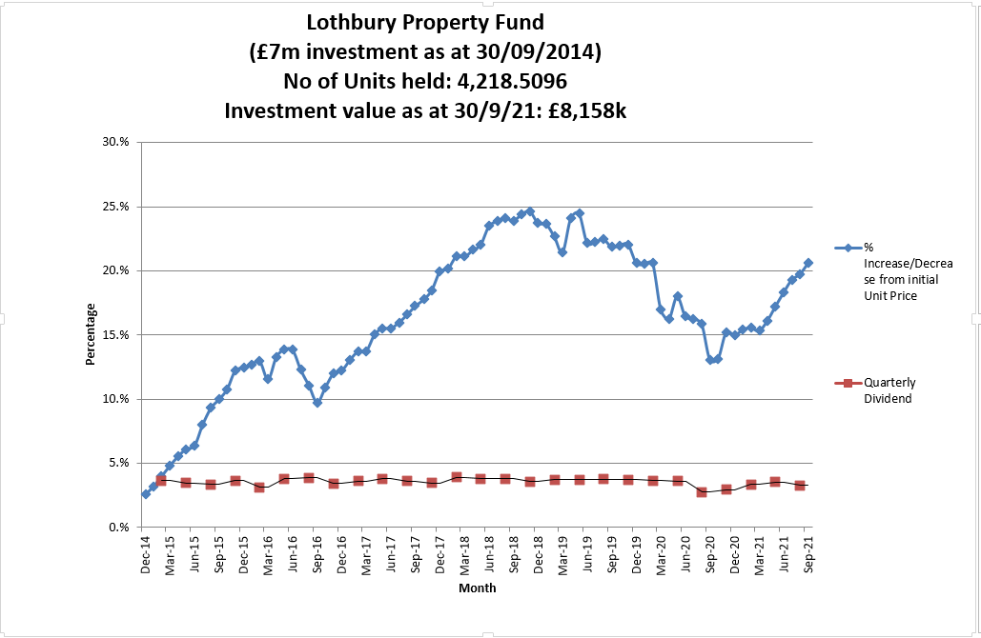

- The investment returns around £60k per quarter.
Multi-Asset Funds
- The council has invested in two multi asset funds as set out in the treasury strategy, Multi-asset funds are able to invest across the investment landscape and may include equities, bonds and cash. This provides a greater degree of diversification than investing in a single asset class. The same accounting rules apply to multi-asset funds as apply to property funds (see paragraph 28)
Artemis Multi Asset Fund
- In accordance with the 2020/21 budget, in line with the treasury strategy, £5m was invested into the Artemis multi asset fund. Since inception the capital value has risen to £5.267m equating in a rise of 3.04% with an average monthly dividend payment of £16.9k giving an average percentage return of 4.06%
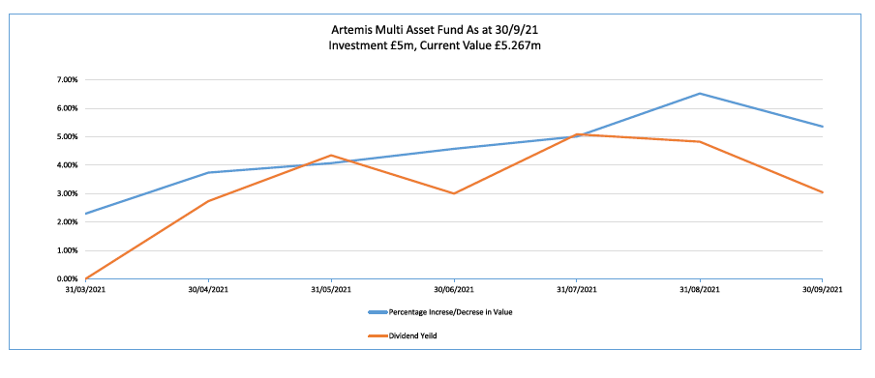
Fidelity Multi Asset Fund
- In accordance with the 2020/21 budget, in line with the treasury strategy, £5m was invested into the Fidelity multi asset fund. Since inception the capital value has risen to £5.071m equating in a rise of 1.42% with an average monthly dividend payment of £15.8k giving an average percentage return of 3.8%
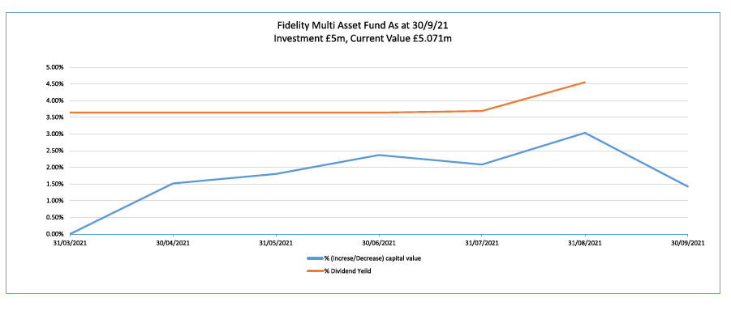
Investment Portfolio
- As at 30th September 2021, the Council’s total investment portfolio amounted to £98.26m, with £10m of this being held in property funds, £10m in Multi asset funds and £28.265m being held in instant access cash facilities, in order to manage day to day cash flow requirements, with the balance being held in banks and loaned to local authorities.
- The graphs below illustrate how the Council’s investment portfolio is distributed, both in terms of the type of investment and counterparty category:
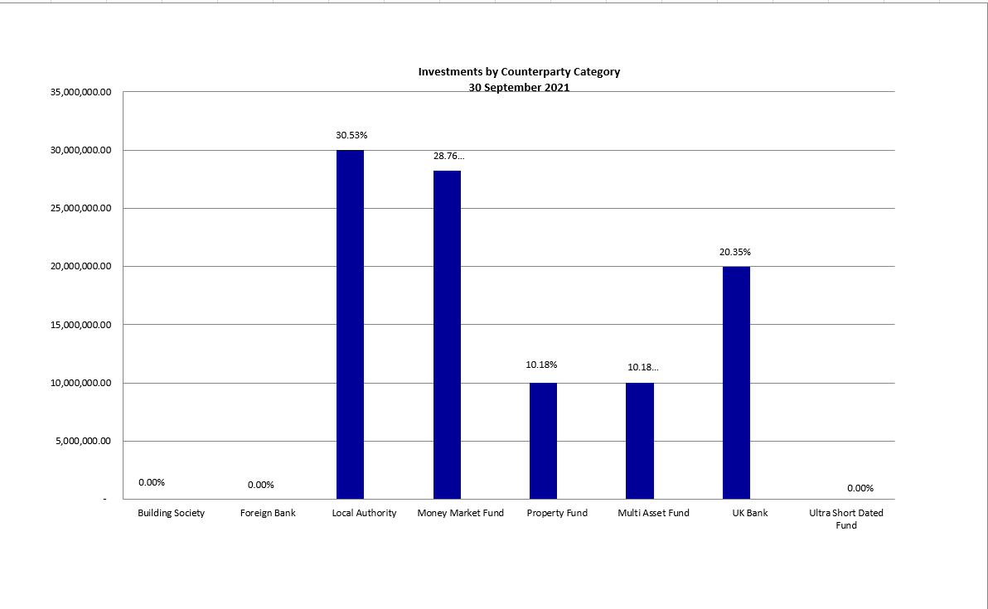

- Fixed deposits and certificates of deposits both have an agreed start and end date which are arranged where possible, to suit the cash flow requirements. However, as mentioned previously, it is also important to keep a proportion in instant access funds.
- The Council’s Treasury Management Strategy limits non-specified investments to 25% (or £25m whichever is greater) of the previous year’s average investment portfolio. This limit is reviewed each year when setting the Strategy in order to ensure a balanced and diversified portfolio of investments. Property funds and investments in excess of 364 days are classified as non-specified due to the associated risk; property funds by nature are high risk due to the volatility of the market. There are several factors that deem longer term investments to be more risky in nature including the risk of interest rate rises and the commitment of cash for longer periods.
- In addition to the above the Council has £5 million invested in the National Homelessness Property Fund (Real Lettings) Resonance developed the Real Lettings Property Fund with leading homelessness charity St Mungo’s. It is the largest impact investment fund in the UK and closed at nearly £57m. The Fund was developed in response to the lack of private rented accommodation accessible to rising numbers of people living in temporary accommodation or otherwise at risk of homelessness in London. This is classified as a service investment undertaken using service delivery powers rather than treasury powers under Section 12 of the Local Government Act 2003. This means the counterparty limit for the £5m loaned to the National Homelessness Property Fund is not taken into account when assessing the residual headroom available for investment in non-specified investments.
- The Strategy defines a specified investment as one that is in sterling, less than one year in duration or, if it is a year or more, can be repaid earlier on request and with counterparties that meet the Council’s credit rating criteria. Additionally, once the duration of a non-specified investment falls below 365 days, it also falls into the Specified category. The maturity profile for the Council’s specified investments (equating to £50m when excluding the instant access cash) is illustrated below.
- The graph below illustrates the same investments by duration period in order to demonstrate duration periods. It is not surprising that the majority of investments have a duration period of six months as this is the limit for most of the banks and building societies with whom the Council may invest. When the opportunity arises, longer investments are arranged to allow for a greater yield.
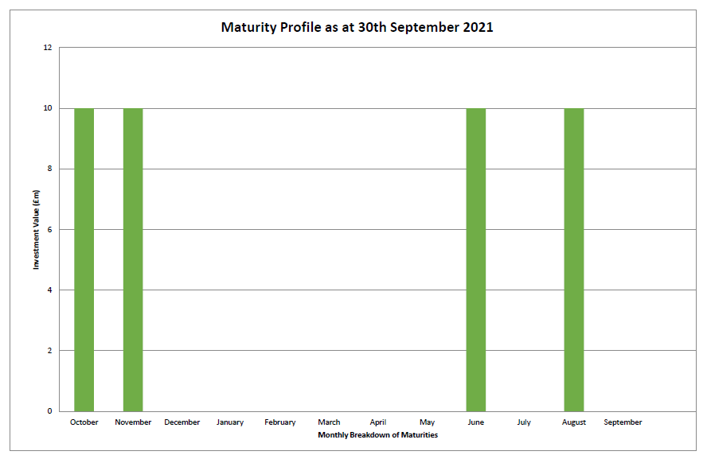
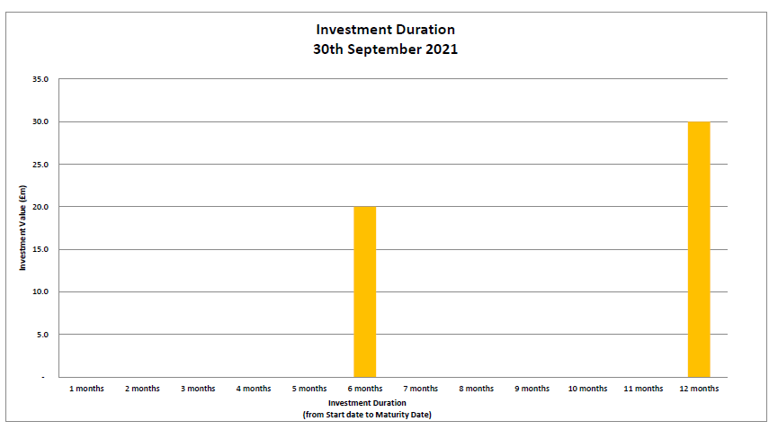
Borrowing
- The Council has not taken on any additional debt during the year to date and so the balance of its external borrowing remains at approximately £198.5 million. This figure relates to funds borrowed from the PWLB to buy out the Housing Revenue Account (HRA) from the subsidy system and relates wholly to Housing with interest repayment being met by the HRA. The Council does not consider that debt restructuring and/or premature repayment would be practical at this time as due to the differential in interest rates, the Council would incur a large premium from the PWLB for doing so. The Council continues to monitor borrowing interest rates and forecasts on a regular basis and will continue to review its position on debt restructuring.
- The Council anticipates borrowing in the future to meet its capital expenditure requirements, including loans to the Housing Company, but does not anticipate any external borrowing during 202122.
Treasury and Prudential Limits for 2021/22
- The Council has operated all of its Treasury Management activity within the parameters set by the Treasury and Prudential indicators in the Treasury Management Strategy for 2021/22.
Other Key Updates
Changes in Risk Appetite
- The 2018 CIPFA Codes and guidance notes have placed enhanced importance on risk management. Where an authority changes its risk appetite e.g. for moving surplus cash into or out of certain types of investment funds or other types of investment instruments, this change in risk appetite and policy should be brought to members’ attention in treasury management update reports. The Council has not made any significant changes to its investment approach at this time. The risk will continue to be managed by understanding the individual investment vehicles and also by considering the appropriate percentage of non-specified investments that can be held in the overall portfolio.

Treasury Advisor
- Treasury advice and market information is provided by Link Asset Services. Information provided by Link Asset Services is used to advise Council Officers when making investment decisions.

Financial Implications
- Any financial implications are contained within the body of this report.

Legal Issues
- There are no legal implications directly relevant to this report.

Level of Risk
- There are no risks in connection with the report’s recommendations. Risk assessment and management is a key part of Treasury Management activity especially in the selection of counterparties when considering investment opportunities. The Council uses external advisors and counterparty credit ratings issued by the rating agencies to assist in this process.

Equalities Impact
- There are no equalities impacts arising directly from this report.

Report author | Bill Lewis
Job title | Financial Accounting Manager
Service area or department | Financial Services
Telephone | 01865 252607
e-mail | blewis@oxford.gov.uk

Background Papers: None

